Assignment day 25

Navie Bayes Classification Results

1 IDV = Pclass Dv =Remaining

Acc Score = 0.578 i.e 57.8%

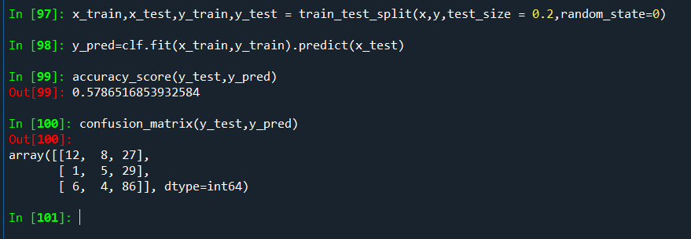

2 IDV =Sex ,DV =Remaining

Acc Score = 0.7191 i.e 71.91%

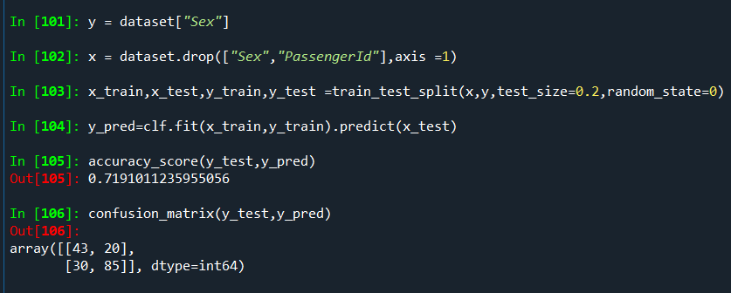

3 IDV = SibSp ,DV = Remaining

Acc Score = 0.6966 i.e 69.66%

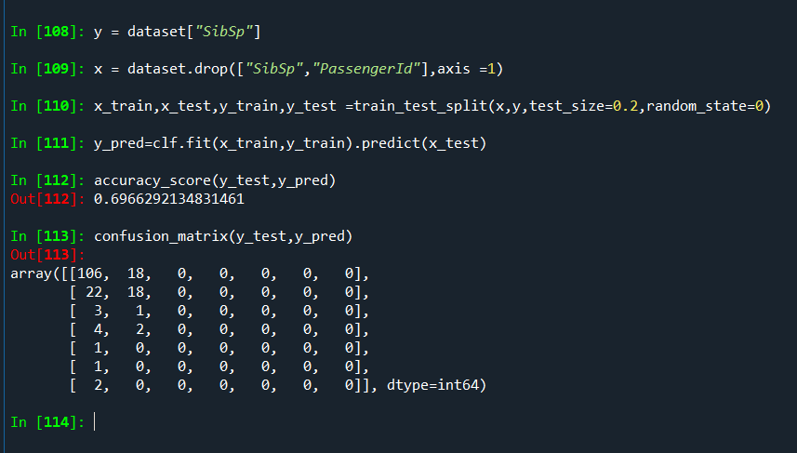

3 IDV = Embarked,DV = Remaining

Acc Score = 0.7415 i.e 74.15%

